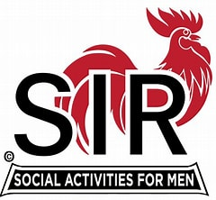

|  |
| --- |
| **Rooster** |

"Of all the creatures on earth, none express more independence and dignity   
with sureness and aplomb than the rooster.  The majesty of his presence is felt   
in every barnyard, and when he crows he can be heard for miles, not in a   
fainthearted crow, but with a noise that calls attention to his being."  
  
Our founders chose the rooster as the official logo to represent the freedom he   
displays around the barnyard. We have paid our dues to the business world   
and now is the time for us to strut and crow a little.  
  
We share the dignity of retirement with one another as members of SIR.