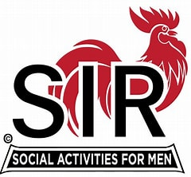

**Whats A SIRS**

Sons In Retirement (SIR) is a non-profit public benefit corporation for retired men. SIR assists men in renewing old friendships and making new friends through SIR activities. Having fun is our goal. We have more than 20,000 members in 150 Branches throughout northern California from Bakersfield to the Oregon border and Lake Tahoe to the Pacific Ocean.  
Membership is open to men retired from full-time occupation, regardless of age, race, color or religion. There are no dues, fees or assessments. Member volunteers staff, administer and govern all Branch activities. Voluntary member contributions provide for these activities. SIR supports no outside cause or interest. We prohibit discussions of politics and religion or the selling of anything to any member. The only requirements to join SIR are that a man be retired, or semi-retired, be able to attend the monthly luncheons, and be sponsored by an active member.  
Each Branch has monthly luncheon meetings where Sirs renew old friendships and establish new ones. Speakers are invited to speak on topical subjects of general interest. Most Branches have summer and winter luncheons where wives, partners and guests are invited.  
Of special interest are Branch activities like golf, bowling, computers, RV’s, investing, genealogy and many other activities of interest to our members.  
An extensive travel program is available to all members and their guests. Travel events vary from one day local excursions to trips of several weeks duration to destinations throughout the world. It is great fun to travel with people you know.  
Our founders chose the rooster as the official SIR logo to represent the freedom he displays around the barnyard. We have paid our dues to the business world and now is the time for us to strut and crow a little.

©2021 by Paradise sirs. Proudly created with Wix.com